Central MN Sexual Assault Center – Advocates for Survivor Accessibility Advisory Group

Group Member Form/contact information
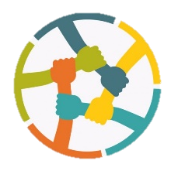
Name:
Title:
- Self-Advocate
- Crime Victim Service Provider
- Disability Service Provider
- Family/Friend of Someone with a Disability
- Disability Advocate
- Interested Community Member
- Other:____________________
Phone: |  |  | E-mail:
Company Name (If Applicable):
City: | State: |  |  | ZIP Code:
What is the best way to keep in contact with you(check one box)?
- phone call
- emails

Discuss your interest for wanting to join A.S.A?

What experiences have you had involving a coordinated crime victim service provider response to sexual assault that you are willing to discuss/share?

What to you hope to accomplish while a member of A.S.A.?

What accommodations might you need in order for A.S.A. meetings to be accessible for you?

Questions, Comments, Concerns or for More Information:

Samantha MSW, LGSW
Services for Women with Disabilities Coordinator
Central MN Sexual Assault Center
15 Riverside Drive NE Saint Cloud, MN 56304
Phone: 320.251.4357
Website: www.CMSAC.org
Email: Spreusser@cmsac.org or CMSAC@cmsac.org

